Nepal College of Information Technology
Assessment
Fall 2010
Program: IT Time: 3 hrs
Semester: Fall (III) FM: 100
Subject: Electronic Circuits PM: 50
Attempt all the questions:
1 a) Obtain the small signal analysis of Common emitter (bypassed) configuration. 7
b) Calculate overall voltage gain in the circuit below for β = 100, r_{c}=10k Ω,r_{e}=25Ω 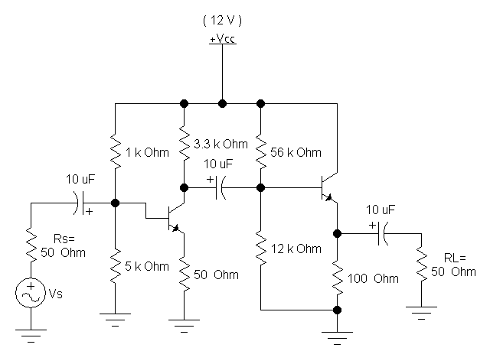 8
2. a) Explain the effect of bypass capacitor on low frequency response. 7
b) The amplifier shown below has mid-band gain V_{L}/V_{S}=50. Find. 8
i) The lower cutoff frequency.
ii) V_{o}/V_{in}.
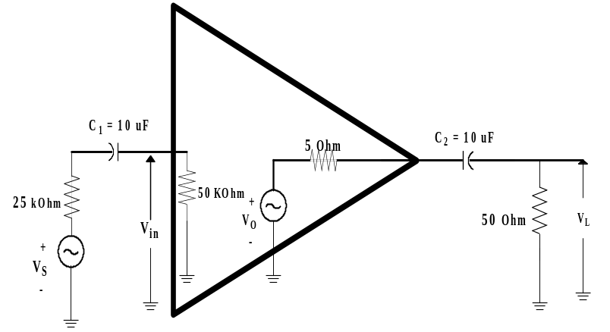
3. a) What is Cross-over distortion? Describe the operation of Complementary symmetry push pull amplifier. 2+5
b) What are the types of feedback connection? For an amplifier with a gain of -1000 and feedback β= -0.5 has a gain change of 35% due to temperature. Calculate the change in gain of the feedback amplifier. 2+6
Or
What are the differences between positive and negative feedback? Derive the expression for the gain of a negative feedback amplifier. 4+4

4. a) What are the necessary conditions for oscillation? Describe RC phase shift oscillator and obtain its oscillation frequency. 2+6
b) ) For a Crystal oscillator its parameters L= 3 H, C=10 µF, R= 5 Ω and mounting capacitance C_{m}=12 µF, find its series and parallel resonance frequency. 7

5. a) Write the characteristics of an Ideal Operational Amplifier? Design an Operational Amplifier circuit that will produce an output equal to –(5V1+2V2+3V3). 2+6
b) Explain Astable Multivibrator with circuit diagram. 7

6. a) What is the difference between regulated and unregulated power supply? Describe how a series voltage regulator provides a regulated output voltage. 3+5
b) For a 4-bit R-2R ladder DAC obtain its overall output voltage. 7
Or
The logic levels used in a 4-bit R-2R ladder DAC are logic 1= +16V and logic 0= 0V. Find the output voltage when the input is 0011 and 1010.

7. Write Short notes on: (Any Two) 5*2=10
a) Class-A amplifier
b) Common collector configuration
c) Successive Approximation ADC

